**Challenge Title: The Cat Ate My Homework**

**Author: MaryEllen Kennel/aka @icanhaspii**

**Points: 100**

**Difficulty: Easy**

**Summary:**

**This challenge is designed to be an easy stego/forensics-carving exercise which utilizes a hex editor to carve out a docx file stuffed inside of a file jpeg file:**

1. **Initial Screen:**

**Fun fact: Cats enjoy gnawing on paper! This innocent little creature ate my homework, can you help me recover it?**

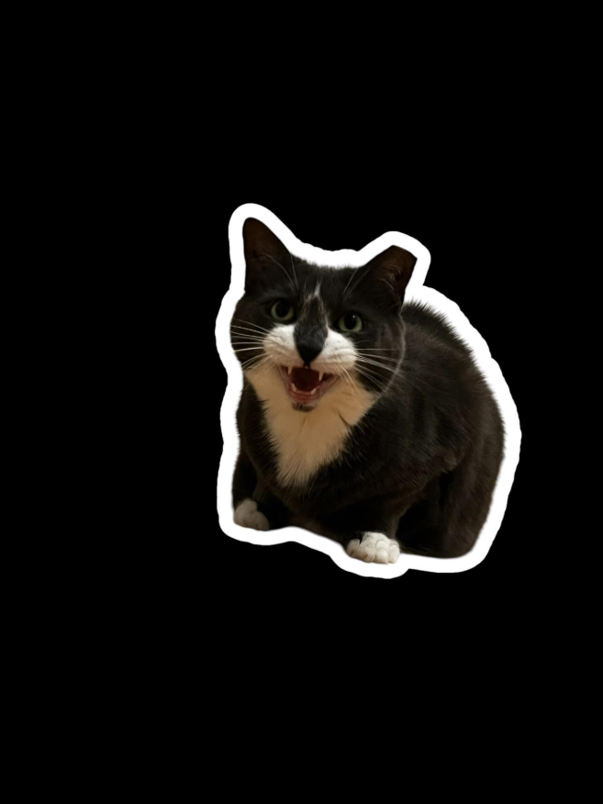

Photo Credit: Chloe Regas

**Solution:**

1. **Open the cat image file in a hex editor (I used HxD:** [**https://mh-nexus.de/en/hxd**](https://mh-nexus.de/en/hxd)**):**

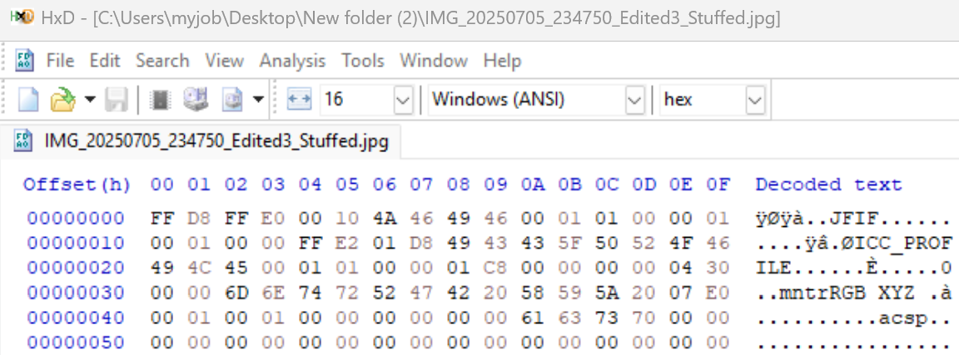

1. **Locate the end-of-image marker - For JPEGs, this marker is typically FF D9:**

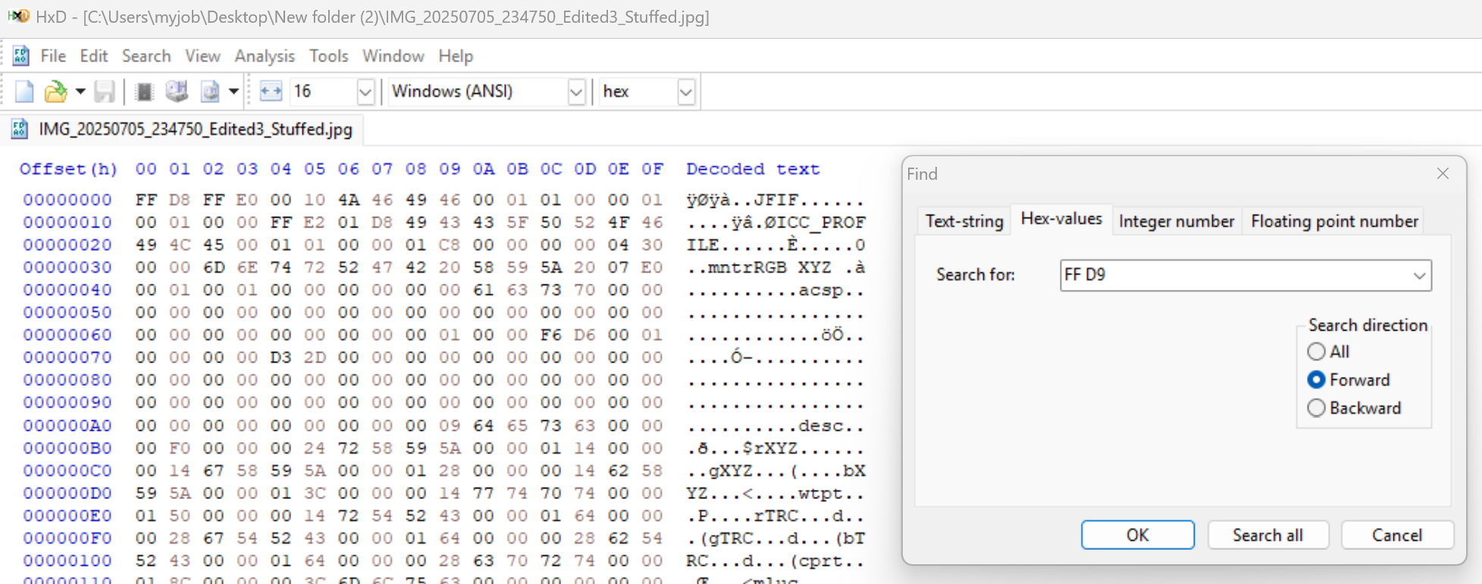

1. **Copy all the hex data of the DOCX file:**

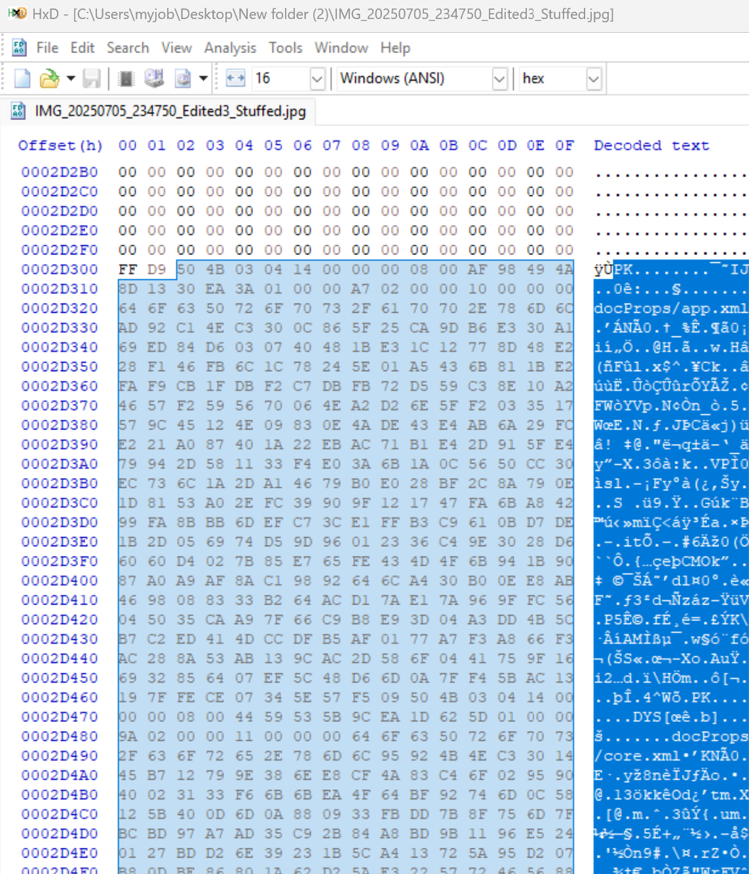



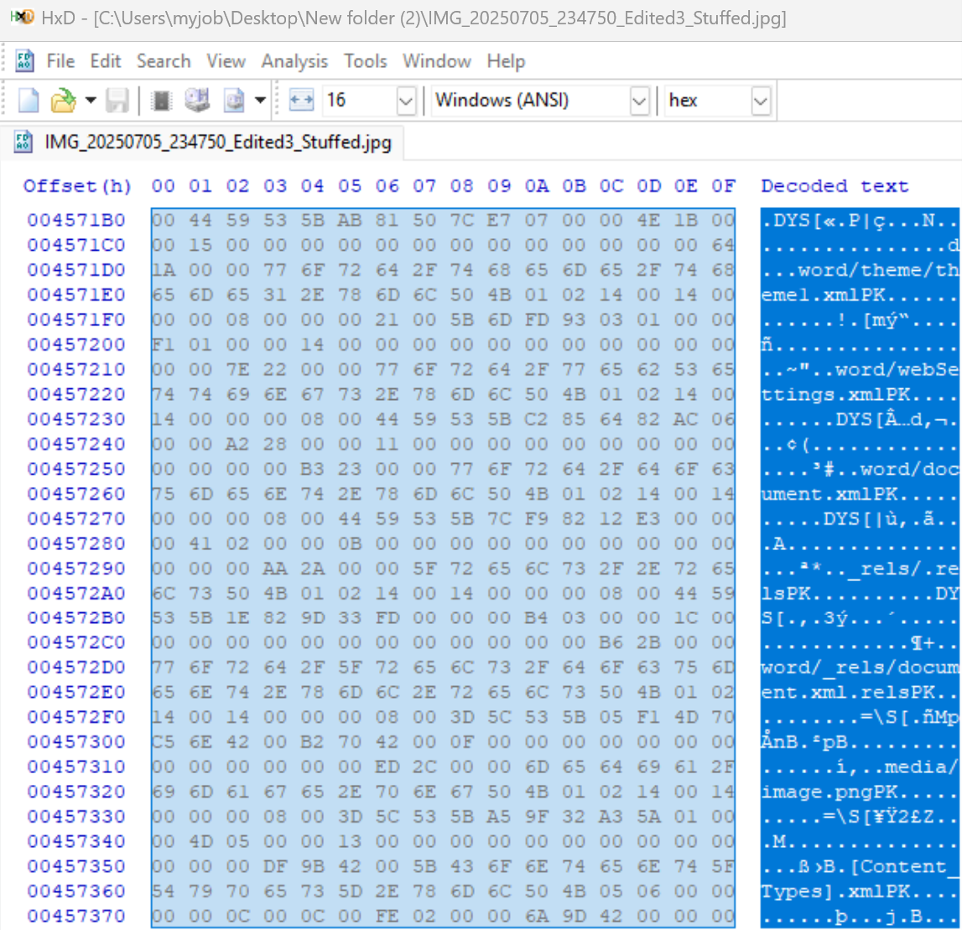



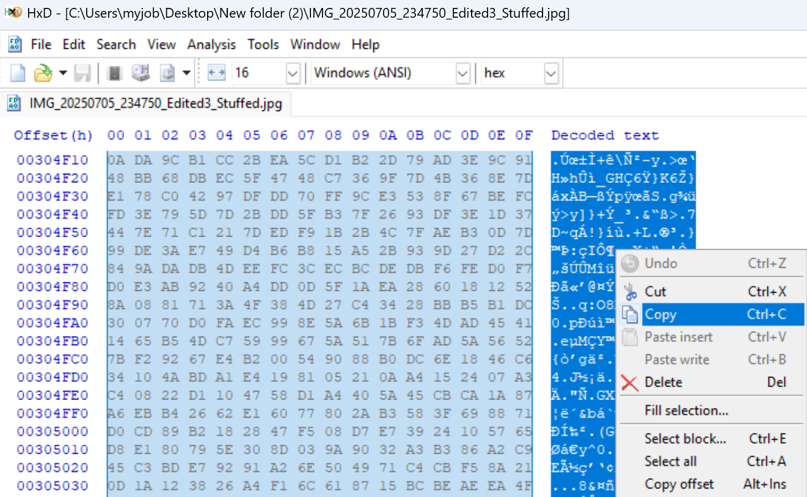

1. **If you see the following error, you can just hit “OK”:**

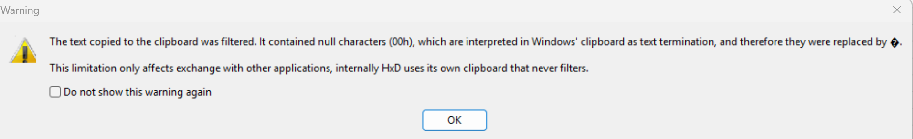

1. **Open a new tab in your hex editor:**

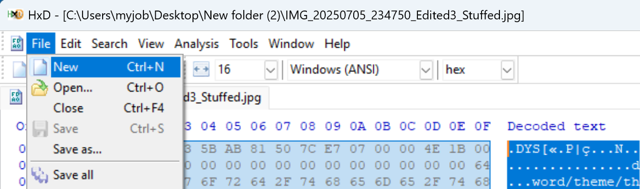

1. **Paste the copied Docx data directly into the new tab of the Hex Editor:**

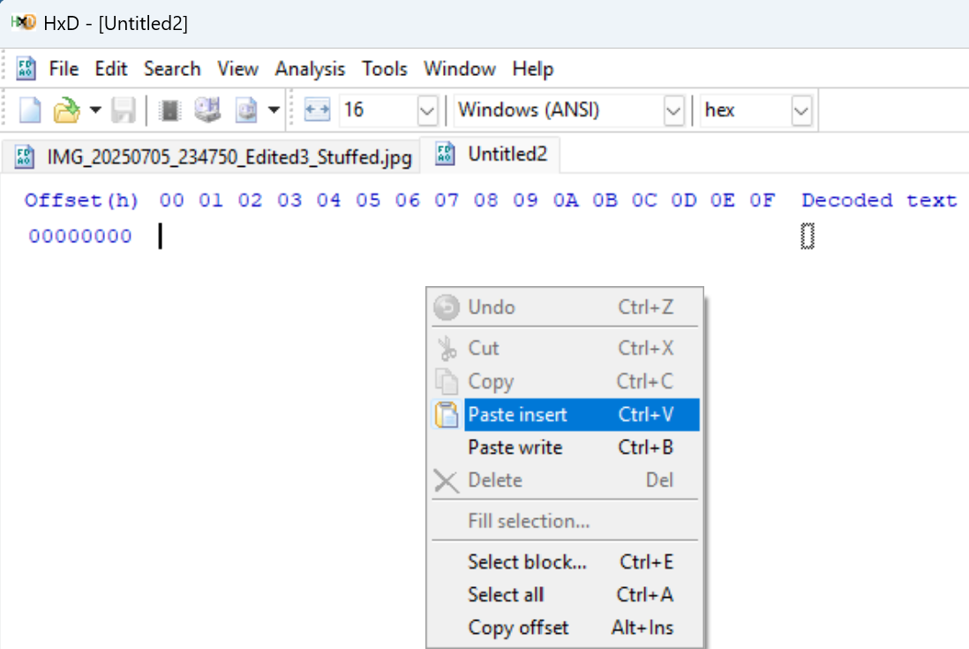

1. **If you see the following error, you can just hit “OK”:**

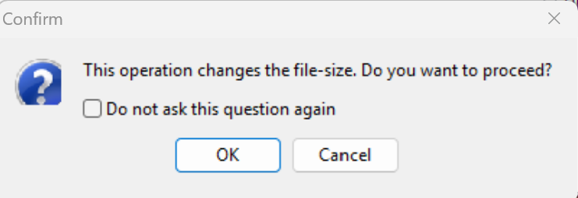

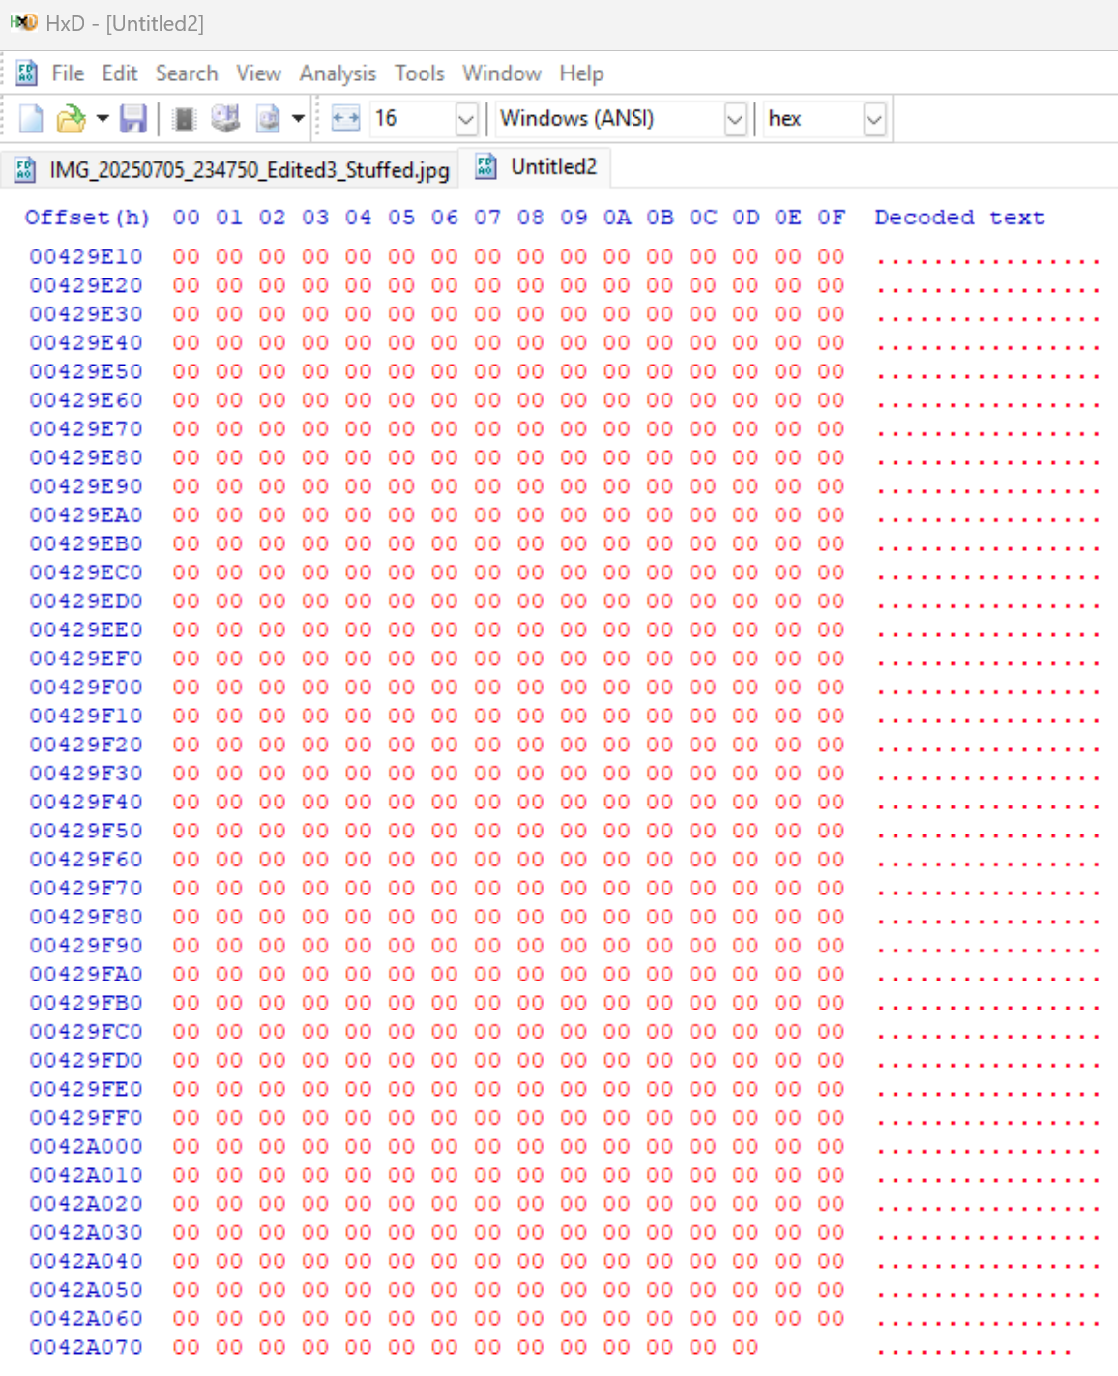

1. **Choose “Save as” in your hex editor:**

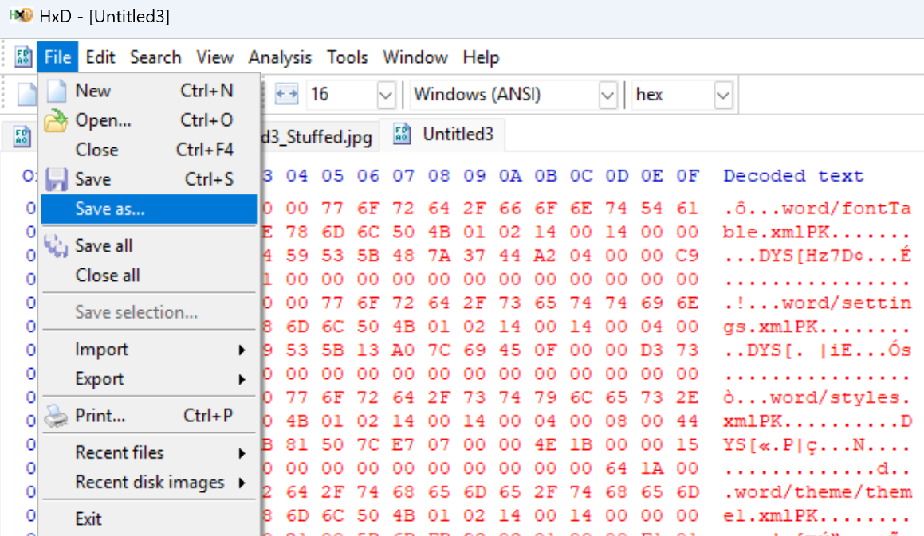

1. **Choose “Save as type” All and give it the .docx extension - I named mine “Carved.docx”:**

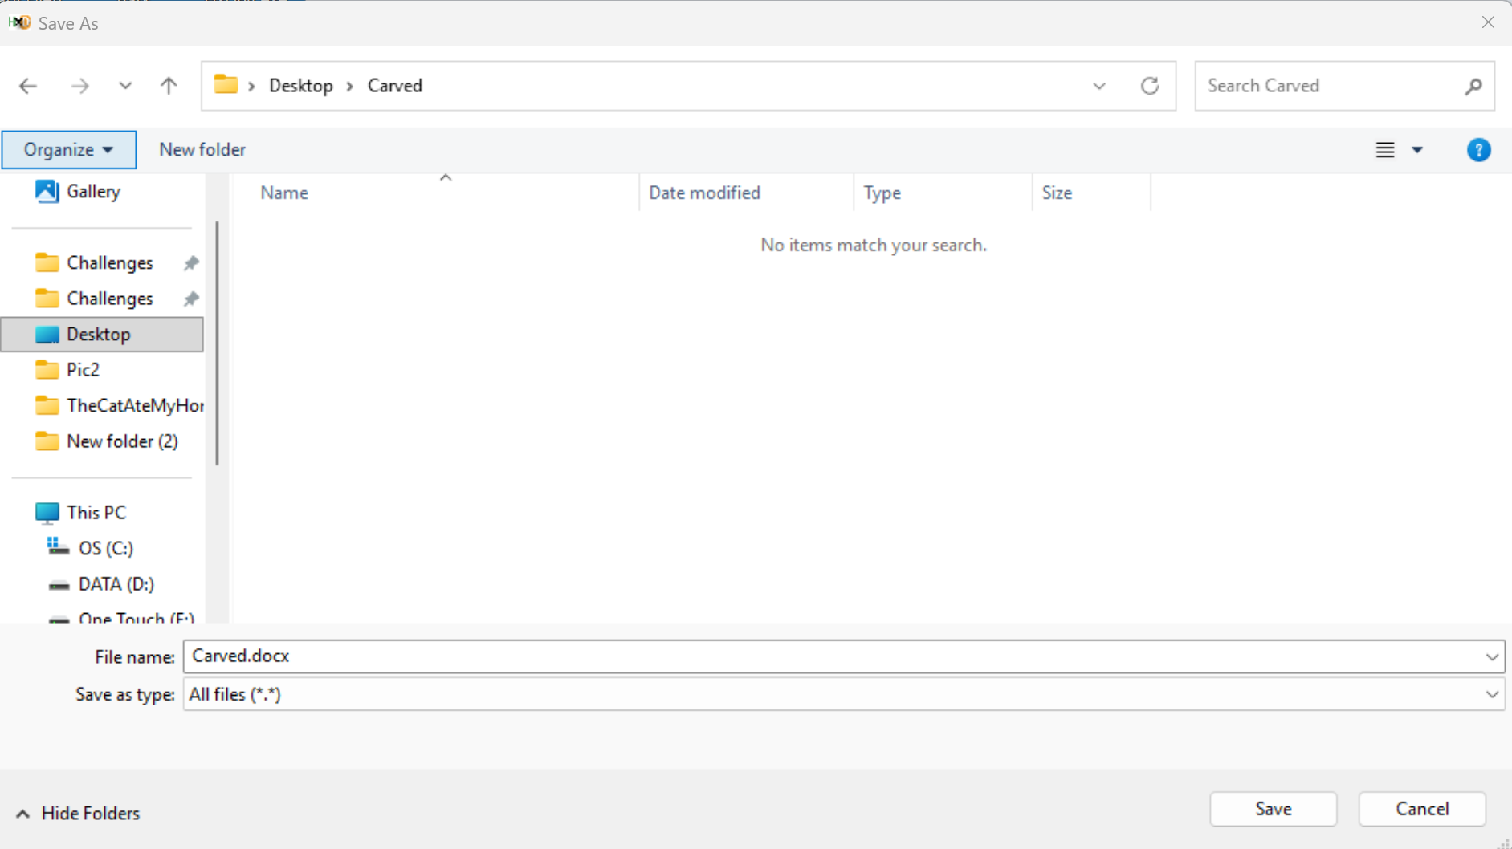

1. **Hit “Save” and you should end up with a fully functional .docx file:**

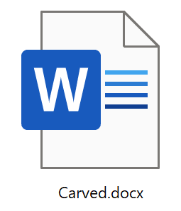

1. **When you open the newly carved file, “Carved.docx”, you should see the flag revealed inside the homework assignment:**

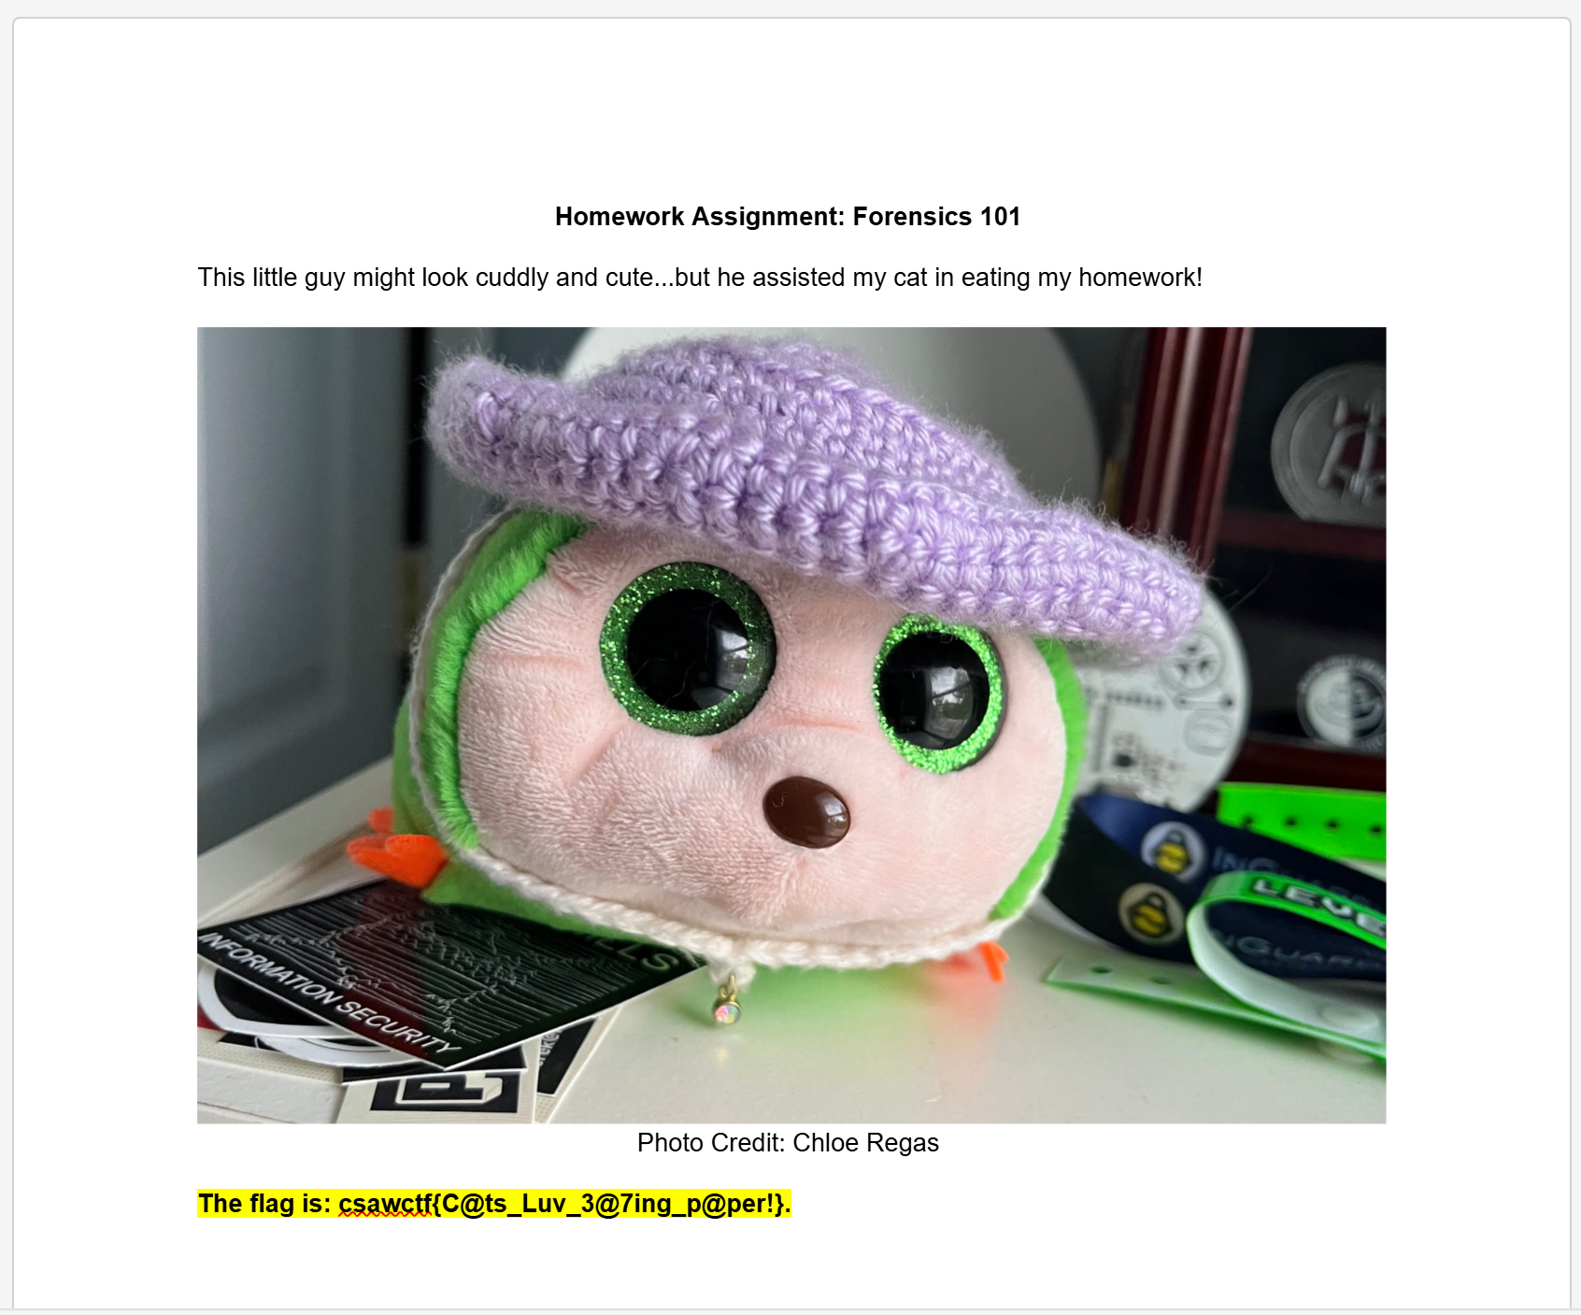

1. **Flag:**

**csawctf{C@ts_Luv_3@7ing_p@per!}.**

##### End of Report #####